**C64 Combi PSU Rev. 0**

**Module Description**

Table of Contents

Introduction 1

External Power Supply 2

The Expansion Module 2

Connectors 3

J1, J2 – Mains connectors 3

J3 – DC-PSU Output 3

J4 – C64 Output 4

J5 – 1541-II or Amiga Output 4

Version 1541-II 4

Version Amiga 4

J6 – 1541-II Output 4

J7, J15 – Panel Meter (+5V) 5

J7 – Current path 5

J15 – Voltage connection 5

J10, J16 – Panel Meter (+12V) 5

J10 – Current path 5

J16 – Voltage connection 5

J11-J14 – Chassis Mount Transformer Connectors 6

Expansion connector – J19 6

Power LED – J8 6

PE connection 7

Fuses 7

Wiring 7

# Introduction

The C64 combi PSU is a power supply board for the Commodore C64 and up to two floppy disk drives 1541-II. Depending on the used external DC-power supply, one of the 1541 connectors can be used for a Commodore AMIGA.

This board connects to mains and it contains a 9V transformer, which provides the 9VAC for the C64. For the DC-Voltages, a variety of power supply modules can be connected externally.

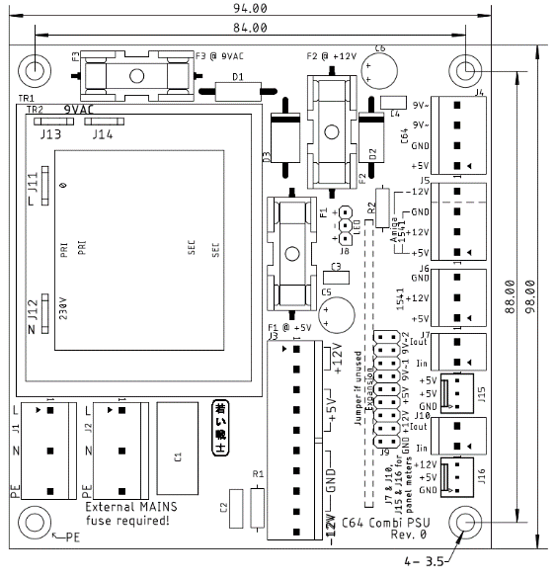

Figure 1: Measures of the board

The board allows a number of alternative placements and optional components:

* There are footprints for two different transformers, a chassis mount transformer can be connected via four spade connectors
* Two panel meters for +5V and +12V can be connected, if not wanted, the connectors do not need to be populated.
* An extension module can be connected, which can measure or control the output voltages
* One connector can provide voltages for either a 1541-II disk drive or an Amiga

# External Power Supply

The external power supply should either have the output voltages +5V (≥3.5A), +12 V (≥1A) for one C64 and two 1541-II floppy disk drives or +5V (≥5A), +12V (≥2A), -12V (≥0.1A). The traces on the PCB are calculated for 4A (+12V, 9VAC), 6A (+5V) and 2.5A (-12V). The fuses have to be picked according to the maximum current of the output voltages and the copper traces.

For best operation (due to voltage drops on the PBC and the cables), it is recommended to adjust the power supply to +5.1V to +5.2V. While adjustment, any devices must not be connected to the PSU. The other voltages need to be checked. A slightly higher output on +12V is also ok.

Suggested PSUs (many other possible):

* Mean Well: RD-50A (+5V @ 6A, +12V @ 2A) (e.g. Mouser: €15.34)
* Mean Well: RT-65B (+5V @ 5A, [+12V @ 2.8A](mailto:+12V%20@%202.8A), -12V @ 0.5A) (e.g. Mouser: 17,43€)

# The Expansion Module

For monitoring or controlling the output voltages of the PolyPower64, an optional Expansion module can be connected to J19. The connector has input and output pins for the 9VAC, the +12V and the +5V. It also offers two GND pins.

In case the Expansion Module is not installed, the pins, mentioned before, have to be bridged with jumpers (rated 3A).

A maximum height of 20mm is assumed for the expansion module.

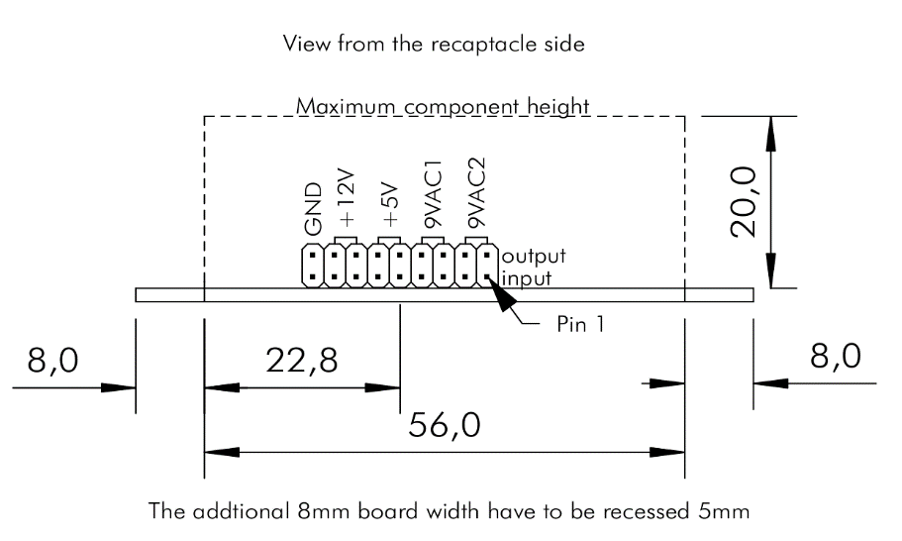

Figure 2: Dimensions of the Expansion Module

The maximum dimensions of the Expansion Module are shown in Figure 2. The length of the module depends on the enclosure of the power supply and the standoffs for the PCB.

Any voltage, that is unused on the expansion module should be bridged (40mil trace!) on there. The same is valid for voltages, which do not have a current measurement or any switch like function.

To prevent slipping of the connectors, the Expansion Module needs to be secured with silicon glue (which is reversible) after testing.

# Connectors

## J1, J2 – Mains connectors

* Molex KK 396 Header, Vertical, Friction Lock, 5 Circuits, Tin (Sn) Plating (Pin 2 and pin 4 removed): P/N 0026604050
* KK 3.96mm Crimp Terminal Housing, Friction Ramp, 5 Circuits, Natural: P/N 09503051
* KK 396 Crimp Terminal 2478, 18-24 AWG, Bag, Brass Tin (Sn): P/N 08500106.

|  |  |
| --- | --- |
| Pin | Signal |
| 1 | L (hot) |
| 3 | N (neutral) |
| 5 | PE (protective earth) |

J1 is for the mains input, J2 is branching to the external DC-PSU.

## J3 – DC-PSU

* Molex KK 396 Header, Vertical, Friction Lock, 10 Circuits, Tin (Sn) Plating:   
  P/N 0026604100
* KK 3.96mm Crimp Terminal Housing, Friction Ramp, 10 Circuits, Natural: P/N 09503101
* KK 396 Crimp Terminal 2478, 18-24 AWG, Bag, Brass Tin (Sn): P/N 08500106.

|  |  |
| --- | --- |
| Pin | Signal |
| 1 | +12V |
| 2 | +12V |
| 3 | +5V |
| 4 | +5V |
| 5 | +5V |
| 6 | GND |
| 7 | GND |
| 8 | GND |
| 9 | GND |
| 10 | -12V |

## J4 – C64 Output

* Molex KK 396 Header, Vertical, Friction Lock, 4 Circuits, Tin (Sn) Plating:   
  P/N 0026604040
* KK 3.96mm Crimp Terminal Housing, Friction Ramp, 4 Circuits, Natural: P/N 09503041
* KK 396 Crimp Terminal 2478, 18-24 AWG, Bag, Brass Tin (Sn): P/N 08500106.

|  |  |
| --- | --- |
| Pin | Signal |
| 1 | +5V |
| 2 | GND |
| 3 | 9VAC2 |
| 4 | 9VAC1 |

## J5 – 1541-II or Amiga Output

### Version 1541-II

For the **1541-II** only populate Pin 1-3. See J6.

### Version Amiga

* Molex KK 396 Header, Vertical, Friction Lock, 4 Circuits, Tin (Sn) Plating:   
  P/N 0026604040
* KK 3.96mm Crimp Terminal Housing, Friction Ramp, 4 Circuits, Natural: P/N 09503041
* KK 396 Crimp Terminal 2478, 18-24 AWG, Bag, Brass Tin (Sn): P/N 08500106.

|  |  |
| --- | --- |
| Pin | Signal |
| 1 | +5V |
| 2 | +12V |
| 3 | GND |
| 4 | -12V |

## J6 – 1541-II Output

* Molex KK 396 Header, Vertical, Friction Lock, 3 Circuits, Tin (Sn) Plating:   
  P/N 0026604030
* KK 3.96mm Crimp Terminal Housing, Friction Ramp, 3 Circuits, Natural: P/N 09503031
* KK 396 Crimp Terminal 2478, 18-24 AWG, Bag, Brass Tin (Sn): P/N 08500106.

|  |  |
| --- | --- |
| Pin | Signal |
| 1 | +5V |
| 2 | +12V |
| 3 | GND |

## J7, J15 – Panel Meter (+5V)

### ~~J7 – Current path~~

The current measurement is not functional with any known Panel Meters. It will be dropped in future revisions.

* Molex KK 396 Header, Vertical, Friction Lock, 2 Circuits, Tin (Sn) Plating:   
  P/N 0026604020
* KK 3.96mm Crimp Terminal Housing, Friction Ramp, 2 Circuits, Natural: P/N 09503021
* KK 396 Crimp Terminal 2478, 18-24 AWG, Bag, Brass Tin (Sn): P/N 08500106.

|  |  |
| --- | --- |
| Pin | Signal |
| 1 | Current in (+) |
| 2 | Current out (-) |

### J15 – Voltage connection

* Molex KK 254 Wire-to-Board Header, Vertical, with Friction Lock, 3 Circuits, Tin (Sn) Plating: P/N 22272031
* KK 254 Crimp Housing, 3 Circuits, Natural: P/N 22-01-3037
* KK 254 Crimp Terminal, 22-30 AWG, Bag, Hot Tin (Sn) Dip Plating: P/N 08500114

|  |  |
| --- | --- |
| Pin | Signal |
| 1 | GND |
| 2 | +5V (supply) |
| 3 | +5V (measurement) |

## J10, J16 – Panel Meter (+12V)

### ~~J10 – Current path~~

The current measurement is not functional with any known Panel Meters. It will be dropped in future revisions.

* Molex KK 396 Header, Vertical, Friction Lock, 2 Circuits, Tin (Sn) Plating:   
  P/N 0026604020
* KK 3.96mm Crimp Terminal Housing, Friction Ramp, 2 Circuits, Natural: P/N 09503021
* KK 396 Crimp Terminal 2478, 18-24 AWG, Bag, Brass Tin (Sn): P/N 08500106.

|  |  |
| --- | --- |
| Pin | Signal |
| 1 | Current in (+) |
| 2 | Current out (-) |

### J16 – Voltage connection

* Molex KK 254 Wire-to-Board Header, Vertical, with Friction Lock, 3 Circuits, Tin (Sn) Plating: P/N 22272031
* KK 254 Crimp Housing, 3 Circuits, Natural: P/N 22012031
* KK 254 Crimp Terminal, 22-30 AWG, Bag, Hot Tin (Sn) Dip Plating: P/N 08500114

|  |  |
| --- | --- |
| Pin | Signal |
| 1 | GND |
| 2 | +5V (supply) |
| 3 | +12V (measurement) |

## J11-J14 – Chassis Mount Transformer Connectors

In case it is desired to use a chassis mount transformer instead of the PCB mount types (TR1 or TR2), some spade connectors (6.3 x 0.8) can be placed. It is recommended to use fully isolated FastOn connectors on the cables.

|  |  |
| --- | --- |
| Connector | Signal |
| J11 | Mains L (hot) |
| J12 | Mains N (neutral) |
| J13 | 9VAC (2) |
| J14 | 9VAC (1) |

## Expansion connector – J19

* Pin header, 2 x 9 circuits, 2.54mm pitch (0.1”)
* Jumper from input to output if not used (jumpers rated 3A)

|  |  |  |  |
| --- | --- | --- | --- |
| Signal | Pin | Pin | Signal |
| Input 9VAC (2) | 1 | 2 | Output 9VAC (2) |
| Input 9VAC (2) | 3 | 4 | Output 9VAC (2) |
| Input 9VAC (1) | 5 | 6 | Output 9VAC (1) |
| Input 9VAC (1) | 7 | 8 | Output 9VAC (1) |
| Input +5V | 9 | 10 | Output +5V |
| Input +5V | 11 | 12 | Output +5V |
| Input +12V | 13 | 14 | Output +12V |
| Input +12V | 15 | 16 | Output +12V |
| GND | 17 | 18 | GND |

If no expansion module is in place, the inputs have to be connected to the corresponding outputs with jumpers (2.54mm, 0.1”).

## Power LED – J8

* Pin header, 1x3 circuits, 2.54mm (0.1”) pitch
* Crimp housing: Dupont crimp housing
* Dupont crimp terminals

It is possible to use a widely available (Ebay, AliExpress etc.) Dupont cable, which can be cut and soldered to the LED.

|  |  |
| --- | --- |
| Pin | Signal |
| 1 | LED + |
| 2 | LED - |
| 3 | LED + |

## PE connection

The marked mounting hole is connected to PE.

# Fuses

Since the rating of the fuses depend on the external power supply, that is used, there can only be recommendations. The copper traces on the PCB are rated for 4A (9VAC, +12V) and 6A (+5V). These are the **absolute maximum ratings** for the fuses. Do not exceed this, even if the power supply is rated higher!

|  |  |  |
| --- | --- | --- |
| Fuse | Voltage | Recommendation |
| F1 | +5V | 3A |
| F2 | +12V | 1.6A |
| F3 | 9VAC | 1.6A |

The ratings above are conservative. For powering an Amiga, higher ratings are required. Refer to the ratings of the original power supply.

The (external) mains fuse depends on the inrush current of the external power supply. The value has to be determined carefully. In case this fuse fails, the rating has to be increased.

# Wiring

This device is connected to mains. Mains voltage is potentially lethal. High currents, that can occur in this device can cause fire hazards. Do not carry out this work, if you are not trained!

Up to four sorts of crimp contacts are required for installing this device:

* FastOn Flat connectors 6.3 x 0.8 (isolated, red) for mains connector/switch
* Fork shaped/ring cable lugs (semi isolated, red) for the power supply
* Molex SPOX/KK 3.96
* Molex KK2.54

The crimp tools for the first two types are cheap. A tool capable of isolated crimps is required. At least the 2nd type has to be crimped, while the first type can be soldered (do not forget the shrinkable sleeve). Crimping is the recommended method.

The latter two contact types can be crimped with the Engineer PA-20 or (probably) the IWISS IWS-2820M. The cables can also be directly solder into the pads of the connectors. This is possible, but not recommended.

A quality control of every crimp is required. That means, the flat connectors and the ring cable lugs must not fall off the cable when pulling it.

It is definitely recommended to order more than just the required amount of each crimp connector/terminal. It is not unlikely, that some crimps don’t work out, depending on the experience with this production method.

The installation of the PSU in a metal enclosure requires connection to PE of all metal parts of this enclosure. These connections need to be proved (at least with a multimeter) after finishing the assembly. One mounting hole of the PCB is connected to the PE of the installation. This is marked “← PE”. Chopper disks are recommended to attain a good connection.

Many metal cases can be used as suitable enclosure for this PSU.

The Hammond 1411P was used for one version of the PSU Combi. It is quite compact (127mm x 152mm x 102mm) and fits the RD-50A. The price is about 16€ (tme.eu/2020).

Another case is the TEKO 384 (203mm x 160mm x 70mm). It is less high, both, the external PSU and the PCB can be mounted flat, which might be easier. The price is about 22€ (reichelt.de/2020).

|  |  |  |
| --- | --- | --- |
| C64 Power Jack | Pin | Voltage |
|  | 1 | - |
| 2 | GND |
| 3 | - |
| 4 | - |
| 5 | +5V |
| 6 | 9VAC(1) |
| 7 | 9VAC(2) |

Table 1: Power jack of the C64

In case, the power cables should stay connected to this PSU, strain reliefs are required. The recommended way is a DIN-jack on the back panel of the power supply and extra cables to have as few cables in the installation as possible.

|  |  |  |
| --- | --- | --- |
| 1541 Power Jack | Pin | Voltage |
|  | 1 | +5V |
| 2 | GND |
| 3 | - |
| 4 | +12V |

Table 2: Power jack of the 1541-II

Table 1 and Table 2 show the power jacks of the C64 and the 1541-II. The view is on the particular contact side. This is identical with the view on the solder side of the respective DIN plugs. The cables soldered to the din plugs should be 0.5mm²/AWG21. It is possible to use 0.75mm²/AWG20 wires, but this might require to clip off some of the wire strands, since the solder cups of the DIN plugs are usually not capable of accepting a wire of this diameter.

After finishing the wiring, it is required to test the complete device. Swapping the voltages by confusing the pins or the wiring will usually damage the connected devices. The +5V should measure between +4.9V and +5.2V. The 9VAC are not regulated and might be quite a bit higher without load. 11VAC are still an acceptable reading.

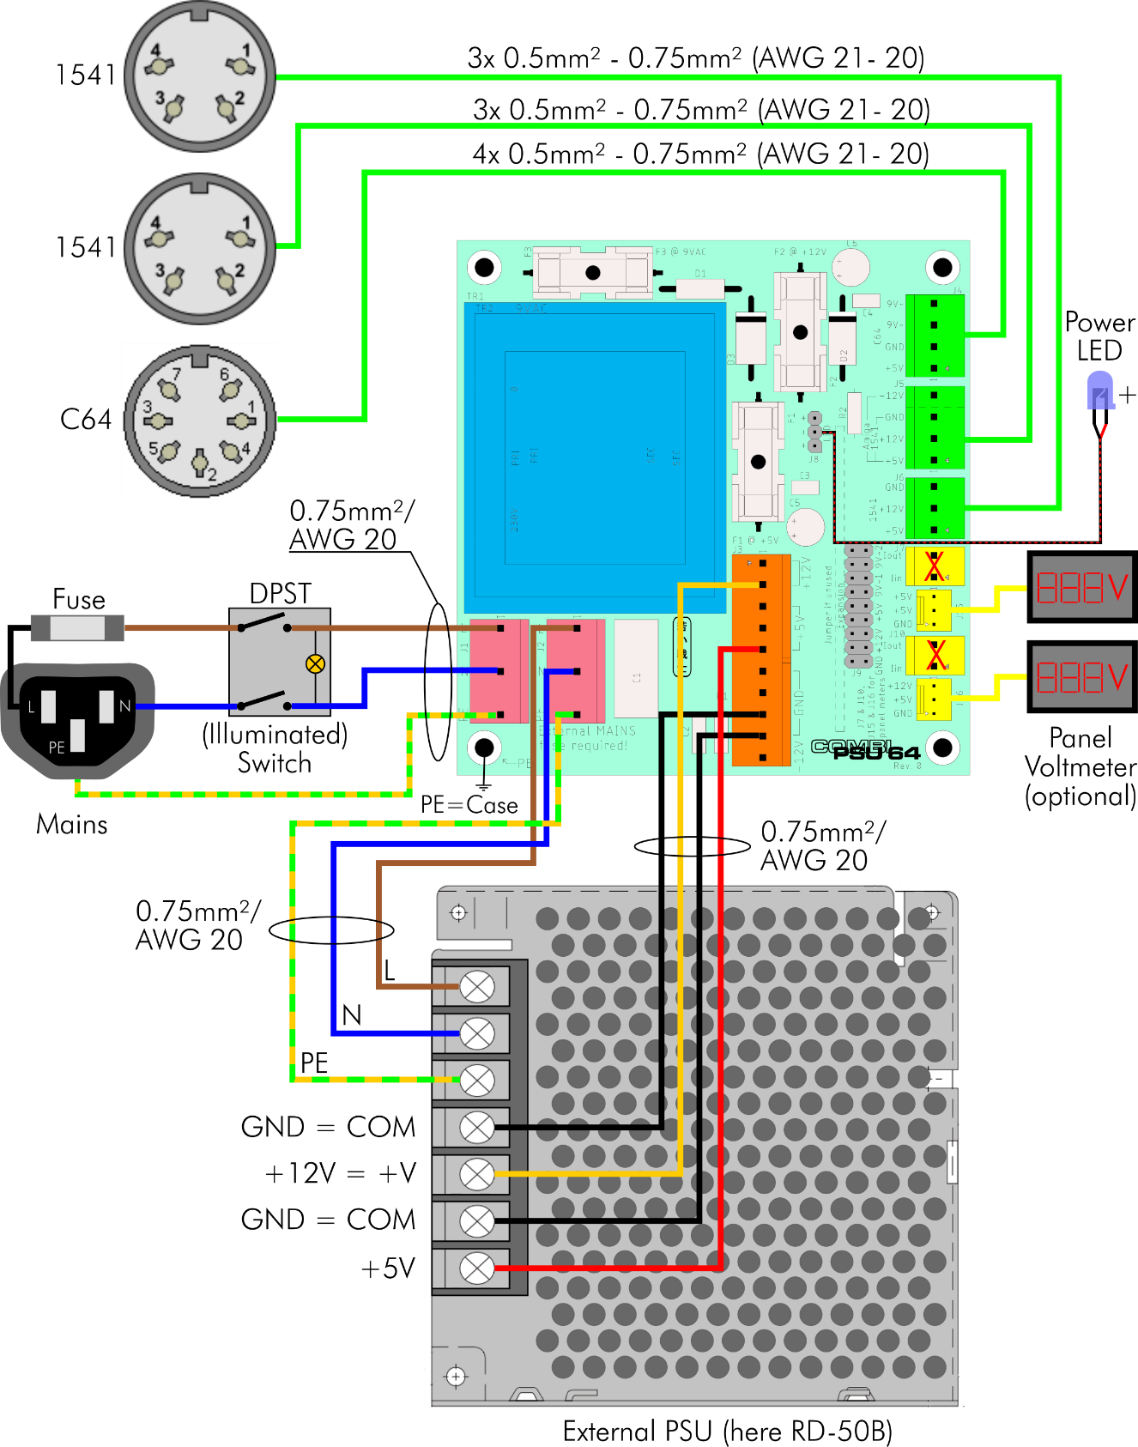

Figure 3: Wiring of the CombiPSU64

A proper PE (protective earth) installation is mandatory. The PE cables should be slightly longer than the L (life/hot) and N (neutral) wires. The purpose is, that in case of mechanical stress, the PE cables are pulled off last.

# Picture gallery

Figure 4 shows two versions of the PSU Combi. Two different external power supplies are used. Left is an XPower open frame PSU, which was used, because it was “in stock”. The right power supply is the Mean Well RD-50A. The both boards are assembled with the different transformer types.

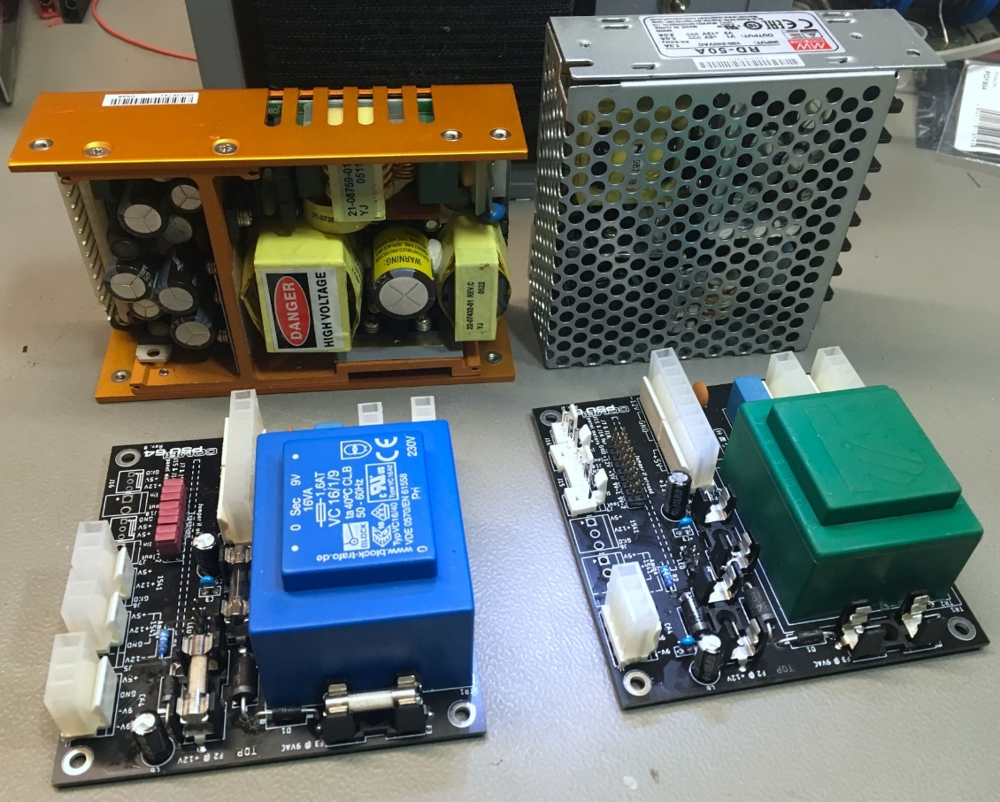

Figure 4: two versions of the PSU Combi

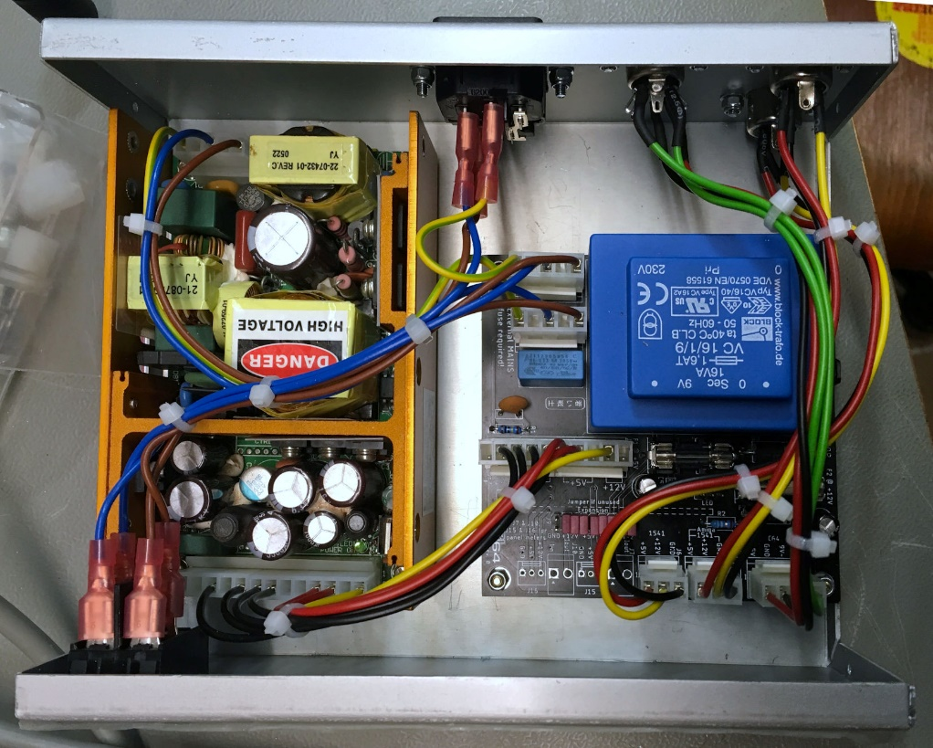

Figure 5: Finished PSU in TEKO 384 case

Figure 5 shows the finished PSU in the TEKO 384 case. The mains switch is on the front. The external PSU and the PCB fit side by side. The PSU can be mounted directly on the bottom of the case, while the PCB sits on 10mm hex bolts. The wiring of the mains and the output jacks require some space, due to the flat connectors and the bending radius of the cables.

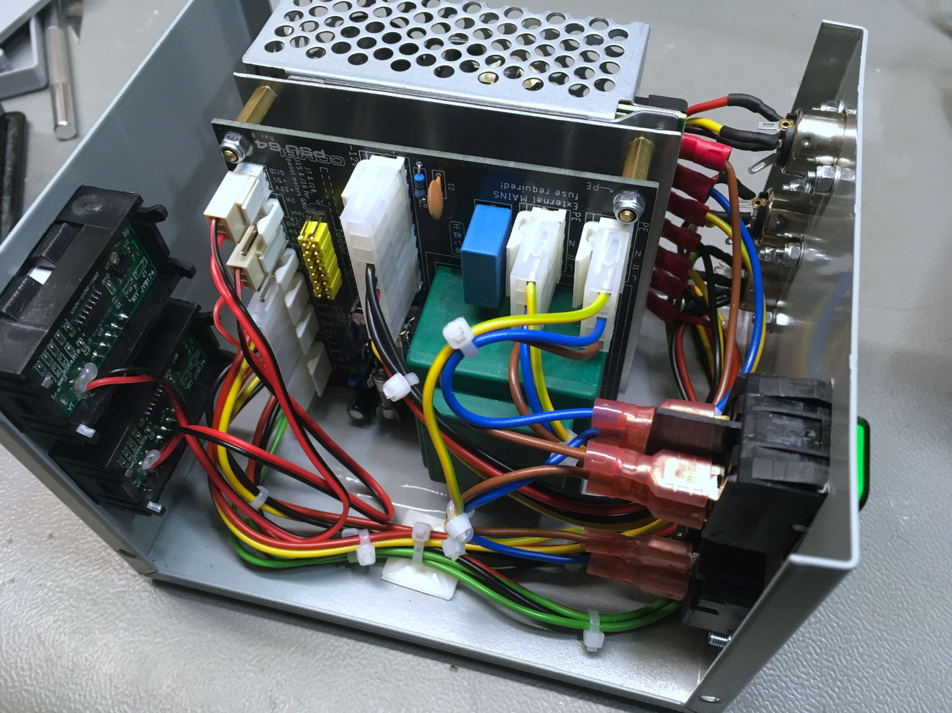

Figure 6: Finished PSU in the Hammond 1411P case

Figure 6 shows the PSU mounted inside the Hammond 1411P case. The RD-50A is mounted upright. The PCB is attached to a fitting panel, which is screwed to the bottom of the PSU and a mounting angle. This is the most compact configuration.

Cable ties and adhesive cable posts provide a clean cable routing. The mains switch is on the back.

Two panel voltmeters are installed. This is not a requirement. The voltmeter should be calibrated with a multimeter to get a useful accuracy.

Figure 7 shows the power jacks mounted to the back panel and the connection to the RD-50A with cable lugs.

Figure 8 shows the back side of the Hammond 1411P case. The mains switch is in the back, the output cables are also in the back. The output cables are detachable, which is a nice feature in case not all outputs are used permanently. In case one or two cables should stay permanently attached, strain reliefs can be mounted on the back panel.

Figure 9 shows the mounting of the RD-50A power supply and the PCB in the Hammond case. The PCB sits on a fitting panel via 15mm hex bolts. The fitting panel is screwed to the bottom of the RD-50A. A 10mm x 10mm aluminum mounting angle is screwed to the fitting panel and mounted to the bottom of the case to provide more stability.

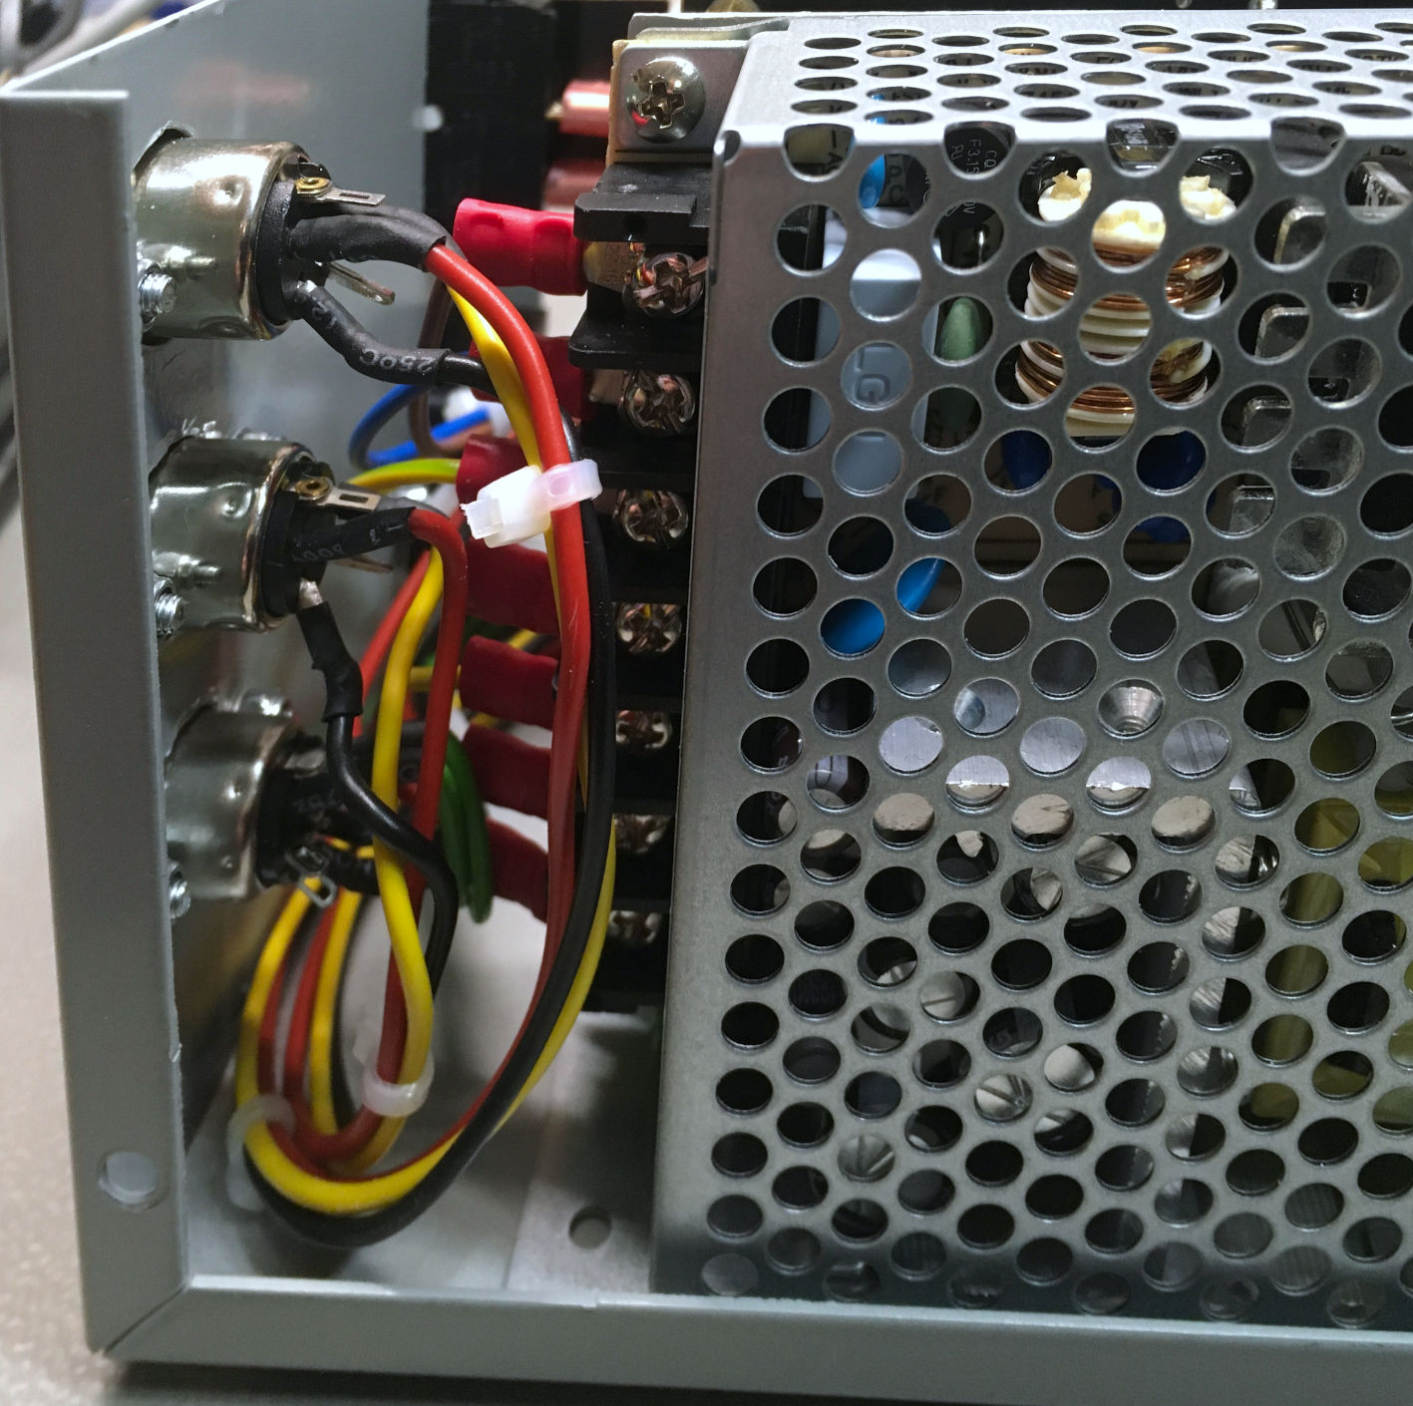

Figure 7: Power jacks and cables to the RD-50A

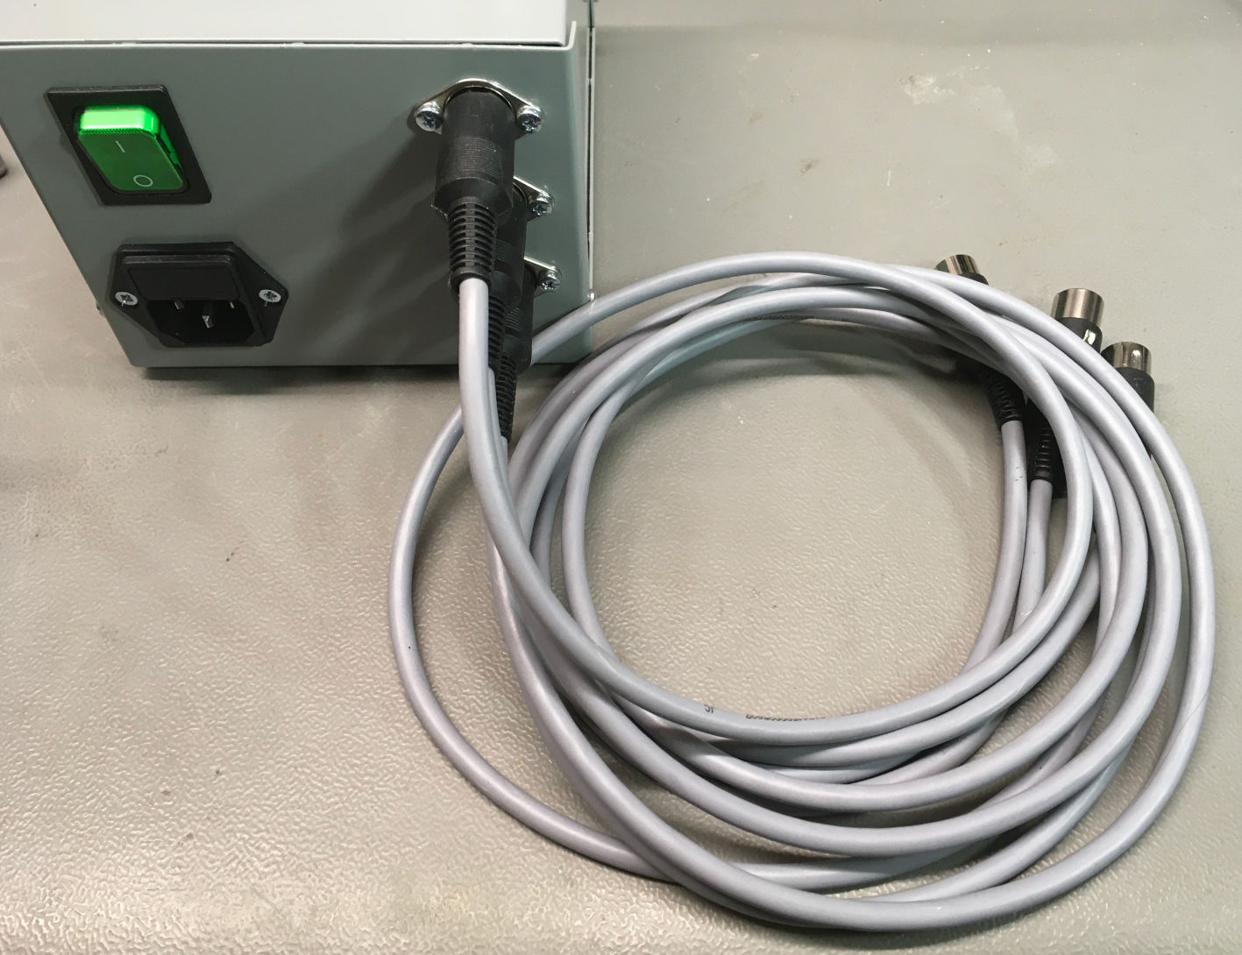

Figure 8: Back side of the Hammond case and output cables

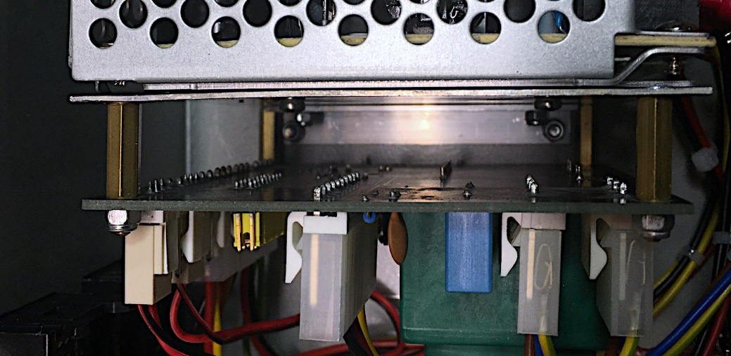

Figure 9: Mounting of the RD-50A and the PCB in the Hammond Case

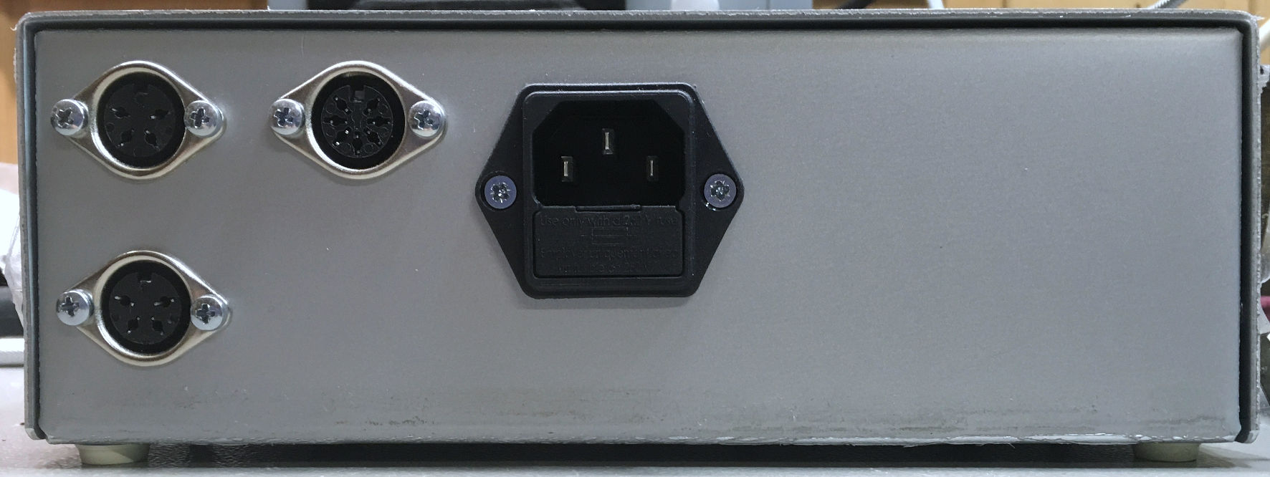

Figure 10: Back of the Teko 384 case

Figure 10 shows the back of the Teko case 384. The (illuminated) mains switch is in the front and also serves as a power indicator.

# Further thoughts

The panel meters are not really required. In case, they are not used, the 5V on the voltage connector of the panel meter can be connected to a USB A jack, which then can power accessories like the RetroTINK video converter. This way, one more power supply can be saved. It was not tested to drive a PI1541 with it, which might require a bit more current.

Since many possible externals PSUs have a wide range input – the RD-50A is capable of 88VAC to 264VAC – the Rev. 1 of the PSU Combi will have an option for a transformer that allows 115V/230V switching.

# Testing

After finishing the power supply, it is very important to test the pinning of the output jacks/cables. A mistake could fry the connected device.

The ratings of the power supply depend on the used components. This way, the mains fuse requires to be determined. Values of 500mA to maybe 1A should be tested. The PSU combi does have an inrush current, so if the fuse is too weak, it will blow frequently. Nevertheless, the fuse should be as weak as possible.